ARE YOU A CHELSEA BOY OR GIRL BETWEEN THE AGES OF 7 AND 15?

Would you like to attend a week of overnight summer camp at

NO CHARGE?



The Rotary Club of Chelsea is looking for 20 children between the ages of 7 and 15 to sponsor at a week of overnight camp at Camp Rotary in Boxford, MA beginning **Sunday, June 29th, 2025 and Sunday July 6th, 2025**.

The Rotary Club of Chelsea will pay all registration fees and tuition. The Rotary Club of Chelsea will also provide transportation to and from Camp Rotary. Some personal expenses incurred while attending the camp will be the responsibility of the child and his/her family. Sponsorships are open to all **Chelsea Residents** who have **NOT** been sponsored by the Rotary Club of Chelsea at Camp Rotary in the past.

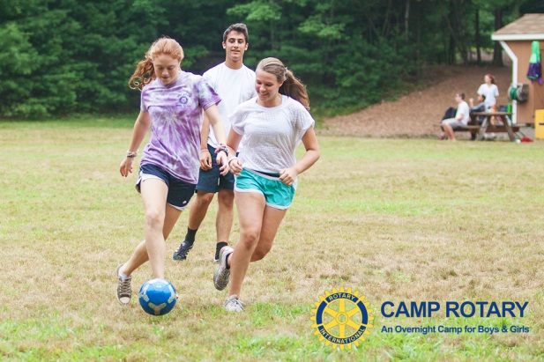

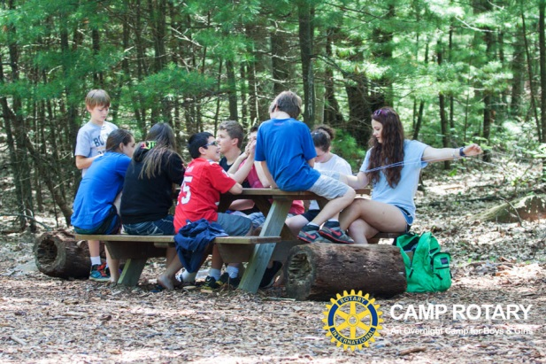

To apply, please send a one-page essay of why the Rotary Club of Chelsea should send you to Camp Rotary this summer. All essays should be mailed or hand delivered by **Monday**

**May 19, 2025 to The Rotary Club of Chelsea, c/o Susan Gallant, 778 Broadway, Chelsea, MA 02150**. **All essays should include your name, address, age** **and telephone number.** A committee of Chelsea Rotary Club members will review all essays. The committee will notify finalists. The camp week will begin Sunday afternoon and end Saturday morning.

GET YOUR ESSAY IN BY MAY 19th TO ENJOY A WEEK OF BOATING, SWIMMING, HIKING, CAMPFIRES AND LOTS MORE FUN SUMMER ACTIVITIES!!